**Microsoft Intune is a cloud-based tool that helps manage devices and apps in an organization. One of its main jobs is to deploy (send and install) applications on users’ devices, like Windows laptops or desktops.**

**How to Deploy a Win32 App Using Microsoft Intune (Simple Steps)**

To install apps on Windows devices using Microsoft Intune, you must change the app files into a special format called **.intunewin**. You can do this using a tool from Microsoft called the **Win32 Content Prep Tool**.

**Steps to follow:**

1. **Download the Tool**  
   First, go to the official Microsoft website and download the **Win32 Content Prep Tool**.
2. **Prepare Your App Files**  
   Put your app files (like .exe, .msi, or .msu) into a folder.  
   Use the tool to turn them into a **.intunewin** file.
3. **Upload to Intune**  
   After you get the .intunewin file, log in to the **Intune admin center**.  
   Upload the file as a **new app**.
4. **Add App Information**  
   Give details about the app, such as:
   * App name
   * Description
   * Privacy policy
   * Install and uninstall commands
5. **Assign the App**  
   Choose the users or groups who should get the app.  
   This tells Intune where to send (deploy) the app.

**Conclusion**

The Intune app deployment process helps IT admins **deliver apps easily and safely** to many devices without needing to go to each one. It saves time and makes app management simple.

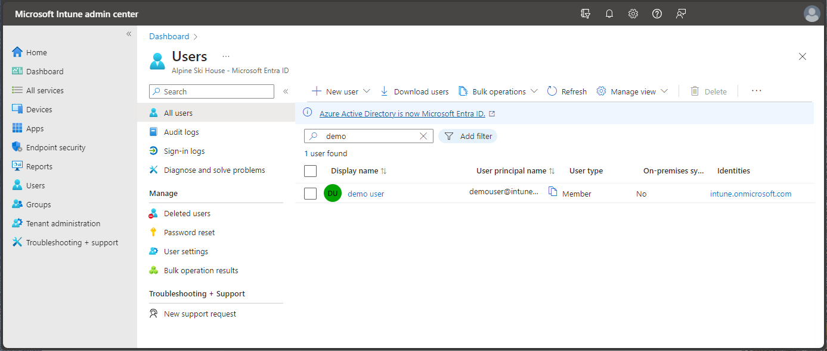

Practical Work:

